# **3****.3. Arquitectura Base**

*Package in package '3. Casos de Uso'*

3.3. Arquitectura Base

Version 1.0 Phase 1.0 Propuesto

Román Luis Raya Rey created on 23/05/2009. Last modified 21/03/2016

## **A****rquitectura Base**

*Package in package '3.3. Arquitectura Base'*

Arquitectura Base

Version 1.0 Phase 1.0 Propuesto

maholc created on 06/06/2012. Last modified 08/04/2016

### **Arquitectura Base diagram**

*Use Case diagram in package 'Arquitectura Base'*

Arquitectura Base

Version 1.0

crossover created on 06/06/2012. Last modified 07/08/2021

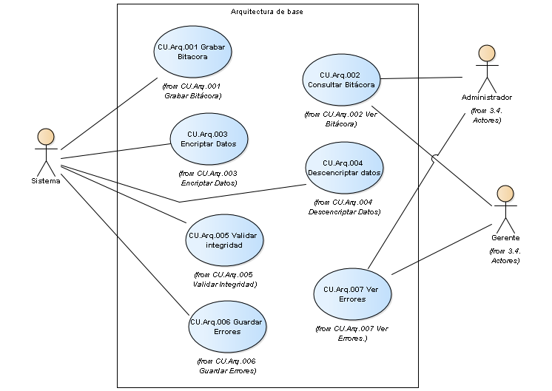

Arquitectura Base

### **C****U.Arq.001 Grabar Bitácora**

*Package in package 'Arquitectura Base'*

CU.Arq.001 Grabar Bitácora

Version 1.0 Phase 1.0 Propuesto

maholc created on 06/06/2012. Last modified 06/06/2012

#### ***CU.Arq.001 Grabar Bitácora diagram***

*Use Case diagram in package 'CU.Arq.001 Grabar Bitácora'*

CU.Arq.001 Grabar Bitácora

Version 1.0

maholc created on 06/06/2012. Last modified 21/06/2021

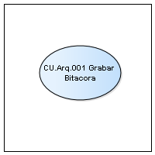

CU.Arq.001 Grabar Bitácora

#### ***CU.Arq.001 Grabar Bitacora***

*UseCase in package 'CU.Arq.001 Grabar Bitácora'*

CU.Arq.001 Grabar Bitacora

Version 1.0 Phase 1.0 Proposed

crossover created on 21/06/2021. Last modified 21/06/2021

| **CONNECTORS** |
| --- |
| **Realization** Source -> Destination  From: CU.CLI.02 - Modificación de Cliente : UseCase, Public  To: CU.Arq.001 Grabar Bitacora : UseCase, Public |

|  |
| --- |
| **Dependency** Source -> Destination  From: CU.COM.01 - Crear Orden de Compra : UseCase, Public  To: CU.Arq.001 Grabar Bitacora : UseCase, Public |

|  |
| --- |
| **Dependency** Source -> Destination  From: CU.PED.03 - Cancelar Pedido : UseCase, Public  To: CU.Arq.001 Grabar Bitacora : UseCase, Public |

|  |
| --- |
| **Dependency** Source -> Destination  From: CU.FAB.04 - Comenzar Fabricación : UseCase, Public  To: CU.Arq.001 Grabar Bitacora : UseCase, Public |

|  |
| --- |
| **Dependency** Source -> Destination  From: CU.FAB.03 - Procesar Pedido : UseCase, Public  To: CU.Arq.001 Grabar Bitacora : UseCase, Public |

|  |
| --- |
| **Dependency** Source -> Destination  From: CU.CLI.01 - Alta de Cliente : UseCase, Public  To: CU.Arq.001 Grabar Bitacora : UseCase, Public |

|  |
| --- |
| **Dependency** Source -> Destination  From: CU.PED.02 - Registrar Pedido : UseCase, Public  To: CU.Arq.001 Grabar Bitacora : UseCase, Public |

|  |
| --- |
| **UseCaseLink** Source -> Destination  From: Sistema : Actor, Public  To: CU.Arq.001 Grabar Bitacora : UseCase, Public |

|  |
| --- |
| **Dependency** Source -> Destination  From: CU.PED.04 - Cerrar Pedido : UseCase, Public  To: CU.Arq.001 Grabar Bitacora : UseCase, Public |

|  |
| --- |
| **Dependency** Source -> Destination  From: CU.FAB.01 - Registrar nuevo Producto : UseCase, Public  To: CU.Arq.001 Grabar Bitacora : UseCase, Public |

|  |
| --- |
| **Dependency** Source -> Destination  From: CU.FAB.02 - Modificar Producto : UseCase, Public  To: CU.Arq.001 Grabar Bitacora : UseCase, Public |

|  |
| --- |
| **PRE-CONDITION CONSTRAINT** |
| Se debe haber realizado una operación que haya alterado los datos de la base de datos  [ Approved, weight is 0 ] |

|  |
| --- |
| **POST CONDITION CONSTRAINT** |
| Se debe añadir un registro en la bitacora  [ Approved, weight is 1 ] |

### **CU.Arq.002 Ver Bitácora**

*Package in package 'Arquitectura Base'*

CU.Arq.002 Ver Bitácora

Version 1.0 Phase 1.0 Propuesto

maholc created on 06/06/2012. Last modified 06/06/2012

#### ***CU.Arq.002 Ver Bitácora diagram***

*Use Case diagram in package 'CU.Arq.002 Ver Bitácora'*

CU.Arq.002 Ver Bitácora

Version 1.0

maholc created on 06/06/2012. Last modified 21/06/2021

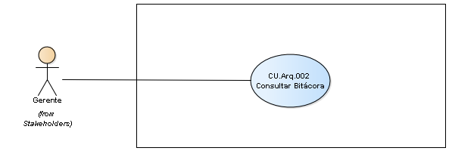

CU.Arq.002 Ver Bitácora

#### ***CU.Arq.002 Consultar Bitácora***

*UseCase in package 'CU.Arq.002 Ver Bitácora'*

CU.Arq.002 Consultar Bitácora

Version 1.0 Phase 1.0 Proposed

crossover created on 21/06/2021. Last modified 21/06/2021

| **CONNECTORS** |
| --- |
| **UseCaseLink** Source -> Destination  From: Administrador : Actor, Public  To: CU.Arq.002 Consultar Bitácora : UseCase, Public |

|  |
| --- |
| **UseCaseLink** Source -> Destination  From: Gerente : Actor, Public  To: CU.Arq.002 Consultar Bitácora : UseCase, Public |

|  |
| --- |
| **UseCaseLink** Source -> Destination  From: Gerente : Actor, Public  To: CU.Arq.002 Consultar Bitácora : UseCase, Public |

|  |
| --- |
| **PRE-CONDITION CONSTRAINT** |
| Se debe ingresar con un usuario con perfil Gerente  [ Approved, weight is 0 ] |

|  |
| --- |
| **POST CONDITION CONSTRAINT** |
| Se mostrará la lista de operaciones realizadas de acuerdo a los filtros seleccionados  [ Approved, weight is 1 ] |

### **CU.Arq.003 Encriptar Datos**

*Package in package 'Arquitectura Base'*

CU.Arq.003 Encriptar Datos

Version 1.0 Phase 1.0 Propuesto

maholc created on 06/06/2012. Last modified 06/06/2012

#### ***CU.Arq.003 Encriptar Datos diagram***

*Use Case diagram in package 'CU.Arq.003 Encriptar Datos'*

CU.Arq.003 Encriptar Datos

Version 1.0

Matias created on 26/06/2012. Last modified 10/06/2021



CU.Arq.003 Encriptar Datos

#### ***CU.Arq.003 Encriptar Datos***

*UseCase in package 'CU.Arq.003 Encriptar Datos'*

CU.Arq.003 Encriptar Datos

Version 1.0 Phase 1.0

Matias created on 26/06/2012. Last modified 26/06/2012

| **CONNECTORS** |
| --- |
| **Include** «include» Source -> Destination  From: CU.Gral.001 Crear Usuario : UseCase, Public  To: CU.Arq.003 Encriptar Datos : UseCase, Public |

|  |
| --- |
| **UseCaseLink** Source -> Destination  From: Sistema : Actor, Public  To: CU.Arq.003 Encriptar Datos : UseCase, Public |

### **CU.Arq.004 Descencriptar Datos**

*Package in package 'Arquitectura Base'*

CU.Arq.004 Descencriptar Datos

Version 1.0 Phase 1.0 Propuesto

maholc created on 06/06/2012. Last modified 06/06/2012

#### ***CU.Arq.004 Descencriptar Datos diagram***

*Use Case diagram in package 'CU.Arq.004 Descencriptar Datos'*

CU.Arq.004 Descencriptar Datos

Version 1.0

MAHOLC created on 26/06/2012. Last modified 26/06/2012



CU.Arq.004 Descencriptar Datos

#### ***CU.Arq.004 Descencriptar datos***

*UseCase in package 'CU.Arq.004 Descencriptar Datos'*

CU.Arq.004 Descencriptar datos

Version 1.0 Phase 1.0

MAHOLC created on 26/06/2012. Last modified 26/06/2012

| **CONNECTORS** |
| --- |
| **UseCaseLink** Source -> Destination  From: Sistema : Actor, Public  To: CU.Arq.004 Descencriptar datos : UseCase, Public |

### **CU.Arq.005 Validar Integridad**

*Package in package 'Arquitectura Base'*

CU.Arq.005 Validar Integridad

Version 1.0 Phase 1.0 Propuesto

maholc created on 06/06/2012. Last modified 06/06/2012

#### ***CU.Arq.005 Validar Integridad diagram***

*Use Case diagram in package 'CU.Arq.005 Validar Integridad'*

CU.Arq.005 Validar Integridad

Version 1.0

MAHOLC created on 06/06/2012. Last modified 26/06/2012



CU.Arq.005 Validar Integridad

#### ***CU.Arq.005 Validar integridad***

*UseCase in package 'CU.Arq.005 Validar Integridad'*

CU.Arq.005 Validar integridad

Version 1.0 Phase 1.0

MAHOLC created on 26/06/2012. Last modified 26/06/2012

| **CONNECTORS** |
| --- |
| **UseCaseLink** Source -> Destination  From: Sistema : Actor, Public  To: CU.Arq.005 Validar integridad : UseCase, Public |

### **CU.Arq.006 Guardar Errores**

*Package in package 'Arquitectura Base'*

CU.Arq.006 Guardar Errores

Version 1.0 Phase 1.0 Propuesto

maholc created on 06/06/2012. Last modified 06/06/2012

#### ***CU.Arq.006 Guardar Errores diagram***

*Use Case diagram in package 'CU.Arq.006 Guardar Errores'*

CU.Arq.006 Guardar Errores

Version 1.0

MAHOLC created on 06/06/2012. Last modified 23/06/2021



CU.Arq.006 Guardar Errores

#### ***CU.Arq.006 Guardar Errores***

*UseCase in package 'CU.Arq.006 Guardar Errores'*

CU.Arq.006 Guardar Errores

Version 1.0 Phase 1.0 Proposed

crossover created on 23/06/2021. Last modified 23/06/2021

| **CONNECTORS** |
| --- |
| **UseCaseLink** Source -> Destination  From: Sistema : Actor, Public  To: CU.Arq.006 Guardar Errores : UseCase, Public |

|  |
| --- |
| **Dependency** Source -> Destination  From: CU.STO.02 - Actualizar Stock : UseCase, Public  To: CU.Arq.006 Guardar Errores : UseCase, Public |

### **CU.Arq.007 Ver Errores.**

*Package in package 'Arquitectura Base'*

CU.Arq.007 Ver Errores.

Version 1.0 Phase 1.0 Propuesto

maholc created on 06/06/2012. Last modified 06/06/2012

#### ***CU.Arq.007 Ver Errores. diagram***

*Use Case diagram in package 'CU.Arq.007 Ver Errores.'*

CU.Arq.007 Ver Errores.

Version 1.0

MAHOLC created on 06/06/2012. Last modified 26/06/2012



CU.Arq.007 Ver Errores.

#### ***CU.Arq.007 Ver Errores***

*UseCase in package 'CU.Arq.007 Ver Errores.'*

CU.Arq.007 Ver Errores

Version 1.0 Phase 1.0

MAHOLC created on 26/06/2012. Last modified 26/06/2012

| **CONNECTORS** |
| --- |
| **UseCaseLink** Source -> Destination  From: Gerente : Actor, Public  To: CU.Arq.007 Ver Errores : UseCase, Public |

|  |
| --- |
| **UseCaseLink** Source -> Destination  From: Administrador : Actor, Public  To: CU.Arq.007 Ver Errores : UseCase, Public |

### **Generales**

*Package in package 'Arquitectura Base'*

Generales

Version 1.0 Phase 1.0 Propuesto

maholc created on 04/06/2012. Last modified 21/03/2016

#### ***Generales diagram***

*Use Case diagram in package 'Generales'*

Generales

Version 1.0

Matias created on 04/06/2012. Last modified 10/06/2012



Generales

#### ***C******U.Gral.001 Crear Usuario***

*Package in package 'Generales'*

CU.Gral.001 Crear Usuario

Version 1.0 Phase 1.0 Propuesto

maholc created on 04/06/2012. Last modified 04/06/2012

##### **CU.Gral.001 Crear Usuario diagram**

*Use Case diagram in package 'CU.Gral.001 Crear Usuario'*

CU.Gral.001 Crear Usuario

Version 1.0

maholc created on 04/06/2012. Last modified 10/06/2021

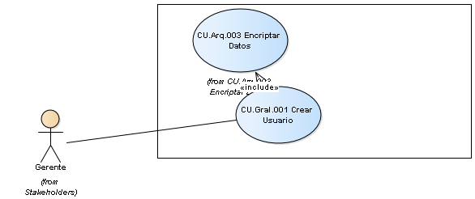

CU.Gral.001 Crear Usuario

##### **CU.Gral.001 Crear Usuario**

*UseCase in package 'CU.Gral.001 Crear Usuario'*

CU.Gral.001 Crear Usuario

Version 1.0 Phase 1.0 Proposed

maholc created on 06/06/2012. Last modified 06/08/2012

| **CONNECTORS** |
| --- |
| **Include** «include» Source -> Destination  From: CU.Gral.001 Crear Usuario : UseCase, Public  To: CU.Arq.003 Encriptar Datos : UseCase, Public |

|  |
| --- |
| **UseCaseLink** Source -> Destination  From: Gerente : Actor, Public  To: CU.Gral.001 Crear Usuario : UseCase, Public |

|  |
| --- |
| **PRE-CONDITION CONSTRAINT** |
| Se hebe haber iniciado sesión con perfil Gerente o Administración.  [ Proposed, weight is 0 ] |

| **SCENARIOS** |
| --- |
| Basic Path. Basic Path  A traves de este caso de uso se creara un nuevo usuario. |

|  |
| --- |
| **POST CONDITION CONSTRAINT** |
| El nuevo usuario habrá sido creado pudiendo iniciar sesion con los datos ingresados previamente.  [ Proposed, weight is 1 ] |

#### ***CU.Gral.002 Modificar Usuario***

*Package in package 'Generales'*

CU.Gral.002 Modificar Usuario

Version 1.0 Phase 1.0 Propuesto

maholc created on 04/06/2012. Last modified 04/06/2012

##### **CU.Gral.002 Modificar Usuario diagram**

*Use Case diagram in package 'CU.Gral.002 Modificar Usuario'*

CU.Gral.002 Modificar Usuario

Version 1.0

Matias created on 04/06/2012. Last modified 08/06/2012

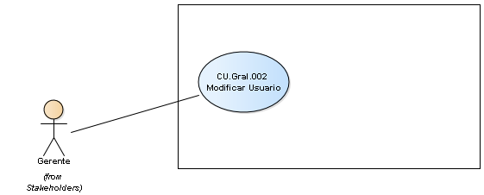

CU.Gral.002 Modificar Usuario

##### **CU.Gral.002 Modificar Usuario**

*UseCase in package 'CU.Gral.002 Modificar Usuario'*

CU.Gral.002 Modificar Usuario

Version 1.0 Phase 1.0 Proposed

Matias created on 08/06/2012. Last modified 06/08/2012

| **CONNECTORS** |
| --- |
| **UseCaseLink** Source -> Destination  From: Gerente : Actor, Public  To: CU.Gral.002 Modificar Usuario : UseCase, Public |

|  |
| --- |
| **PRE-CONDITION CONSTRAINT** |
| Haber creado un usuario anteriormente y estar logueado con perfil Gerente o Administrador.  [ Proposed, weight is 0 ] |

| **SCENARIOS** |
| --- |
| Basic Path. Basic Path  A traves de este caso de uso se podran modificar los datos de un Usuario. |

|  |
| --- |
| **POST CONDITION CONSTRAINT** |
| El usuario poseera sus datos actualizados.  [ Approved, weight is 1 ] |

#### ***CU.Gral.003 Deshabilitar Usuario***

*Package in package 'Generales'*

CU.Gral.003 Deshabilitar Usuario

Version 1.0 Phase 1.0 Propuesto

maholc created on 04/06/2012. Last modified 04/06/2012

##### **CU.Gral.003 Deshabilitar Usuario diagram**

*Use Case diagram in package 'CU.Gral.003 Deshabilitar Usuario'*

CU.Gral.003 Deshabilitar Usuario

Version 1.0

Matias created on 04/06/2012. Last modified 08/06/2012

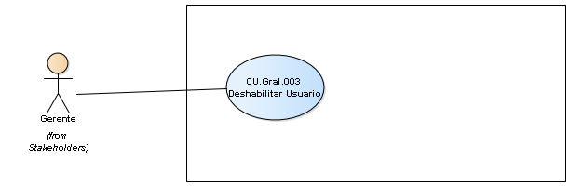

CU.Gral.003 Deshabilitar Usuario

##### **CU.Gral.003 Deshabilitar Usuario**

*UseCase in package 'CU.Gral.003 Deshabilitar Usuario'*

CU.Gral.003 Deshabilitar Usuario

Version 1.0 Phase 1.0 Proposed

Matias created on 08/06/2012. Last modified 08/06/2012

| **CONNECTORS** |
| --- |
| **UseCaseLink** Source -> Destination  From: Gerente : Actor, Public  To: CU.Gral.003 Deshabilitar Usuario : UseCase, Public |

|  |
| --- |
| **PRE-CONDITION CONSTRAINT** |
| Debe existir un usuario y haber iniciado sesion como Gerente.  [ Proposed, weight is 0 ] |

| **SCENARIOS** |
| --- |
| Basic Path. Basic Path  El usuario podrá deshabilitar un usuario actual. |

|  |
| --- |
| **POST CONDITION CONSTRAINT** |
| El usuario seleccionado estara deshabilitado de forma que perdera el acceso al sistema.  [ Proposed, weight is 1 ] |

#### ***CU.Gral.004 Habilitar Usuario***

*Package in package 'Generales'*

CU.Gral.004 Habilitar Usuario

Version 1.0 Phase 1.0 Propuesto

maholc created on 04/06/2012. Last modified 04/06/2012

##### **CU.Gral.004 Habilitar Usuario diagram**

*Use Case diagram in package 'CU.Gral.004 Habilitar Usuario'*

CU.Gral.004 Habilitar Usuario

Version 1.0

Matias created on 04/06/2012. Last modified 08/06/2012

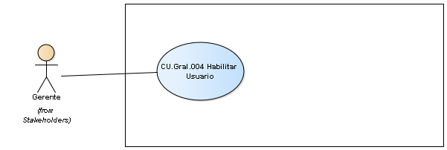

CU.Gral.004 Habilitar Usuario

##### **CU.Gral.004 Habilitar Usuario**

*UseCase in package 'CU.Gral.004 Habilitar Usuario'*

CU.Gral.004 Habilitar Usuario

Version 1.0 Phase 1.0 Proposed

Matias created on 08/06/2012. Last modified 08/06/2012

| **CONNECTORS** |
| --- |
| **UseCaseLink** Source -> Destination  From: Gerente : Actor, Public  To: CU.Gral.004 Habilitar Usuario : UseCase, Public |

|  |
| --- |
| **PRE-CONDITION CONSTRAINT** |
| Debe existir un usuario previamente deshabilitado y estar logueado con el perfil de Gerente.  [ Proposed, weight is 0 ] |

| **SCENARIOS** |
| --- |
| Basic Path. Basic Path  Mediante este caso de uso se habilitará nuevamente a un usuario para que pueda hacer uso del sistema. |

|  |
| --- |
| **POST CONDITION CONSTRAINT** |
| El usuario seleccionado es habilitado para el uso del sistema.  [ Proposed, weight is 1 ] |

#### ***CU.Gral.005 Ingresar al sistema***

*Package in package 'Generales'*

CU.Gral.005 Ingresar al sistema

Version 1.0 Phase 1.0 Propuesto

maholc created on 04/06/2012. Last modified 04/06/2012

##### **CU.Gral.005 Ingresar al sistema diagram**

*Use Case diagram in package 'CU.Gral.005 Ingresar al sistema'*

CU.Gral.005 Ingresar al sistema

Version 1.0

Matias created on 04/06/2012. Last modified 08/06/2012

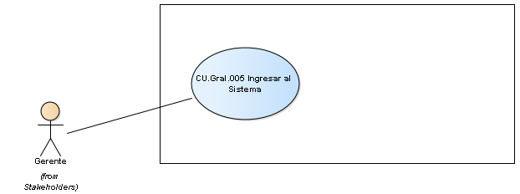

CU.Gral.005 Ingresar al sistema

##### **CU.Gral.005 Ingresar al Sistema**

*UseCase in package 'CU.Gral.005 Ingresar al sistema'*

CU.Gral.005 Ingresar al Sistema

Version 1.0 Phase 1.0

Matias created on 08/06/2012. Last modified 08/06/2012

| **CONNECTORS** |
| --- |
| **UseCaseLink** Source -> Destination  From: Gerente : Actor, Public  To: CU.Gral.005 Ingresar al Sistema : UseCase, Public |

|  |
| --- |
| **PRE-CONDITION CONSTRAINT** |
| No haber iniciado sesion en el sistema.  [ Proposed, weight is 0 ] |

| **SCENARIOS** |
| --- |
| Basic Path. Basic Path  A traves de este caso de uso el usuario podrá acceder al sistema. |

|  |
| --- |
| **POST CONDITION CONSTRAINT** |
| El usuario estara logueado en el sistema para poder utilizarlo según sus respectivos permisos.  [ Proposed, weight is 1 ] |

#### ***CU.Gral.006 Salir del sistema***

*Package in package 'Generales'*

CU.Gral.006 Salir del sistema

Version 1.0 Phase 1.0 Propuesto

maholc created on 04/06/2012. Last modified 04/06/2012

##### **CU.Gral.006 Salir del sistema diagram**

*Use Case diagram in package 'CU.Gral.006 Salir del sistema'*

CU.Gral.006 Salir del sistema

Version 1.0

maholc created on 04/06/2012. Last modified 25/06/2012

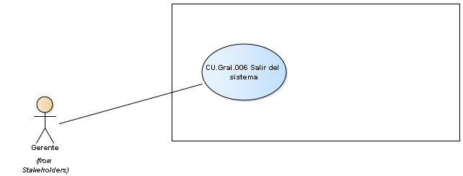

CU.Gral.006 Salir del sistema

##### **CU.Gral.006 Salir del sistema**

*UseCase in package 'CU.Gral.006 Salir del sistema'*

CU.Gral.006 Salir del sistema

Version 1.0 Phase 1.0 Proposed

maholc created on 08/06/2012. Last modified 08/06/2012

| **CONNECTORS** |
| --- |
| **UseCaseLink** Source -> Destination  From: Gerente : Actor, Public  To: CU.Gral.006 Salir del sistema : UseCase, Public |

|  |
| --- |
| **PRE-CONDITION CONSTRAINT** |
| Haber iniciado sesion en el sistema.  [ Proposed, weight is 0 ] |

| **SCENARIOS** |
| --- |
| Basic Path. Basic Path  El usuario se podrá desconectar del sistema, perdiendo así la posibilidad de realizar sus actividades correspondientes |

|  |
| --- |
| **POST CONDITION CONSTRAINT** |
| Se finaliza la sesion en el sistema.  [ Proposed, weight is 1 ] |

#### ***CU.Gral.007 Crear Familia***

*Package in package 'Generales'*

CU.Gral.007 Crear Familia

Version 1.0 Phase 1.0 Propuesto

maholc created on 04/06/2012. Last modified 04/06/2012

##### **CU.Gral.007 Crear Familia diagram**

*Use Case diagram in package 'CU.Gral.007 Crear Familia'*

CU.Gral.007 Crear Familia

Version 1.0

maholc created on 04/06/2012. Last modified 10/06/2021

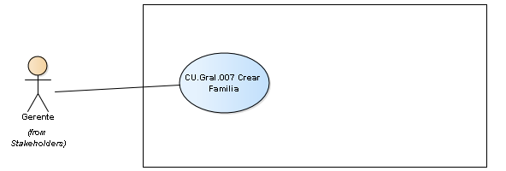

CU.Gral.007 Crear Familia

##### **CU.Gral.007 Crear Familia**

*UseCase in package 'CU.Gral.007 Crear Familia'*

CU.Gral.007 Crear Familia

Version 1.0 Phase 1.0

maholc created on 08/06/2012. Last modified 10/06/2012

| **CONNECTORS** |
| --- |
| **UseCaseLink** Source -> Destination  From: Gerente : Actor, Public  To: CU.Gral.007 Crear Familia : UseCase, Public |

|  |
| --- |
| **PRE-CONDITION CONSTRAINT** |
| Haberse logueado con perfil de Gerente.  [ Proposed, weight is 0 ] |

| **SCENARIOS** |
| --- |
| Basic Path. Basic Path  El usuario podrá crear una Familia pudiendo asigna los permisos (o patentes del mismo). |

|  |
| --- |
| **POST CONDITION CONSTRAINT** |
| La familia sera guardada en el sistema y podrá ser asignada a un usuario.  [ Proposed, weight is 1 ] |

#### ***CU.Gral.008 Modificar Familia***

*Package in package 'Generales'*

CU.Gral.008 Modificar Familia

Version 1.0 Phase 1.0 Propuesto

maholc created on 04/06/2012. Last modified 04/06/2012

##### **CU.Gral.008 Modificar Familia diagram**

*Use Case diagram in package 'CU.Gral.008 Modificar Familia'*

CU.Gral.008 Modificar Familia

Version 1.0

Matias created on 04/06/2012. Last modified 10/06/2012

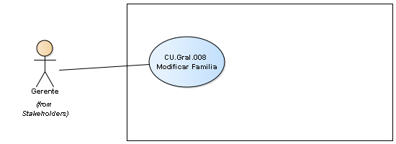

CU.Gral.008 Modificar Familia

##### **CU.Gral.008 Modificar Familia**

*UseCase in package 'CU.Gral.008 Modificar Familia'*

CU.Gral.008 Modificar Familia

Version 1.0 Phase 1.0 Proposed

Matias created on 10/06/2012. Last modified 10/06/2012

| **CONNECTORS** |
| --- |
| **UseCaseLink** Source -> Destination  From: Gerente : Actor, Public  To: CU.Gral.008 Modificar Familia : UseCase, Public |

|  |
| --- |
| **PRE-CONDITION CONSTRAINT** |
| Tener por lo menos una familia existente y haber iniciado sesion como Gerente.  [ Proposed, weight is 0 ] |

|  |
| --- |
| La familia poseera datos actualizados, y los permisos asociados a la familia que posee un usuario serán modificados automáticamente.  [ Proposed, weight is 1 ] |

| **SCENARIOS** |
| --- |
| Basic Path. Basic Path  A traves de este caso de uso el usuario podrá modificar las caracteristicas de una Familia. |

#### ***CU.Gral.009 Borrar Familia***

*Package in package 'Generales'*

CU.Gral.009 Borrar Familia

Version 1.0 Phase 1.0 Propuesto

maholc created on 04/06/2012. Last modified 04/06/2012

##### **CU.Gral.009 Borrar Familia diagram**

*Use Case diagram in package 'CU.Gral.009 Borrar Familia'*

CU.Gral.009 Borrar Familia

Version 1.0

Matias created on 04/06/2012. Last modified 10/06/2012

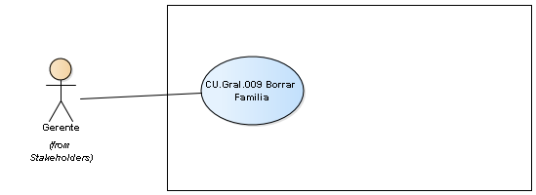

CU.Gral.009 Borrar Familia

##### **CU.Gral.009 Borrar Familia**

*UseCase in package 'CU.Gral.009 Borrar Familia'*

CU.Gral.009 Borrar Familia

Version 1.0 Phase 1.0 Proposed

Matias created on 10/06/2012. Last modified 10/06/2012

| **CONNECTORS** |
| --- |
| **UseCaseLink** Source -> Destination  From: Gerente : Actor, Public  To: CU.Gral.009 Borrar Familia : UseCase, Public |

|  |
| --- |
| **PRE-CONDITION CONSTRAINT** |
| Debe existir por lo menos una Famlia y estar logueado con el perfil "Gerente"  [ Proposed, weight is 0 ] |

| **SCENARIOS** |
| --- |
| Basic Path. Basic Path  Con este caso de uso se podra borrar una familia. |

|  |
| --- |
| **POST CONDITION CONSTRAINT** |
| Se habra borrado una Familia y los permisos pertinentes a los usuarios seran borrados.  [ Approved, weight is 1 ] |

#### ***CU.Gral.010 Crear Patente***

*Package in package 'Generales'*

CU.Gral.010 Crear Patente

Version 1.0 Phase 1.0 Propuesto

maholc created on 04/06/2012. Last modified 04/06/2012

##### **CU.Gral.010 Crear Patente diagram**

*Use Case diagram in package 'CU.Gral.010 Crear Patente'*

CU.Gral.010 Crear Patente

Version 1.0

Matias created on 04/06/2012. Last modified 10/06/2012

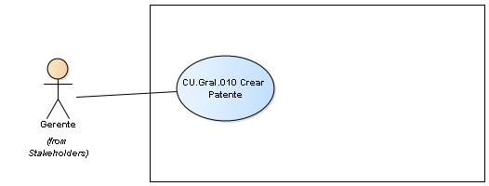

CU.Gral.010 Crear Patente

##### **CU.Gral.010 Crear Patente**

*UseCase in package 'CU.Gral.010 Crear Patente'*

CU.Gral.010 Crear Patente

Version 1.0 Phase 1.0

Matias created on 10/06/2012. Last modified 10/06/2012

| **CONNECTORS** |
| --- |
| **UseCaseLink** Source -> Destination  From: Gerente : Actor, Public  To: CU.Gral.010 Crear Patente : UseCase, Public |

|  |
| --- |
| **PRE-CONDITION CONSTRAINT** |
| Se debe estar logueado con el perfil "Gerente".  [ Proposed, weight is 0 ] |

|  |
| --- |
| Se habrá creado una nueva patente que será asignada a un usuario o a una familia existente.  [ Proposed, weight is 1 ] |

| **SCENARIOS** |
| --- |
| Basic Path. Basic Path  El usuario podrá crear una patente de permisos. |

#### ***CU.Gral.011 Modificar Patente***

*Package in package 'Generales'*

CU.Gral.011 Modificar Patente

Version 1.0 Phase 1.0 Propuesto

maholc created on 04/06/2012. Last modified 04/06/2012

##### **CU.Gral.011 Modificar Patente diagram**

*Use Case diagram in package 'CU.Gral.011 Modificar Patente'*

CU.Gral.011 Modificar Patente

Version 1.0

Matias created on 04/06/2012. Last modified 10/06/2012

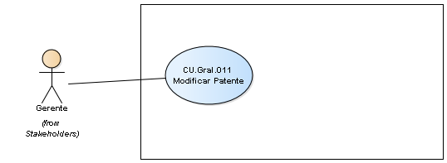

CU.Gral.011 Modificar Patente

##### **CU.Gral.011 Modificar Patente**

*UseCase in package 'CU.Gral.011 Modificar Patente'*

CU.Gral.011 Modificar Patente

Version 1.0 Phase 1.0

Matias created on 10/06/2012. Last modified 10/06/2012

| **CONNECTORS** |
| --- |
| **UseCaseLink** Source -> Destination  From: Gerente : Actor, Public  To: CU.Gral.011 Modificar Patente : UseCase, Public |

|  |
| --- |
| **PRE-CONDITION CONSTRAINT** |
| Que exista una patente y estar logueado con perfil de "Gerente".  [ Proposed, weight is 0 ] |

|  |
| --- |
| Se habra actualizado una patente y los usuario que posean dicha patente tendran sus permisos actualizados.  [ Proposed, weight is 1 ] |

| **SCENARIOS** |
| --- |
| Basic Path. Basic Path  A traves de este caso de uso el usuario podrá modificar las caracteristicas de una Patente |

#### ***CU.Gral.012 Borrar Patente***

*Package in package 'Generales'*

CU.Gral.012 Borrar Patente

Version 1.0 Phase 1.0 Propuesto

maholc created on 04/06/2012. Last modified 04/06/2012

##### **CU.Gral.012 Borrar Patente diagram**

*Use Case diagram in package 'CU.Gral.012 Borrar Patente'*

CU.Gral.012 Borrar Patente

Version 1.0

Matias created on 04/06/2012. Last modified 10/06/2012

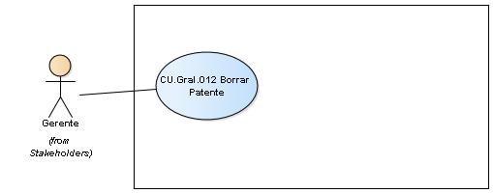

CU.Gral.012 Borrar Patente

##### **CU.Gral.012 Borrar Patente**

*UseCase in package 'CU.Gral.012 Borrar Patente'*

CU.Gral.012 Borrar Patente

Version 1.0 Phase 1.0

Matias created on 10/06/2012. Last modified 10/06/2012

| **CONNECTORS** |
| --- |
| **UseCaseLink** Source -> Destination  From: Gerente : Actor, Public  To: CU.Gral.012 Borrar Patente : UseCase, Public |

| **SCENARIOS** |
| --- |
| Basic Path. Basic Path  Mediante este caso de uso el usuario podrá borrar una patente existente en el sistema. |

| **CONSTRAINTS** |
| --- |
| Invariant. Debe existir una patente y estar logueado con el perfil de "Gerente".  [ Proposed, weight is 0. ] |

|  |
| --- |
| Invariant. Se habra borrado una patente actual y los permisos del usuario seran removidos.  [ Proposed, weight is 1. ] |